# Student name: Victor Larsson

# Background

Use Matlab and Simulink to solve tasks below.

Use the example scripts in “Assign3.zip” uploaded at Canvas. Use the latest version published

The main Simulink model is “EDR100_Model3.slx”.

Good practice for plots:

* Give the plot a descriptive title, e.g. to know what the data source is.
* Always label all axes with physical quantity and the relevant unit.
* Try to scale the data with prefixes (milli, kilo…) so that the data labels on the axes are as short as possible, and hence easy to read.
* Simulink plots will include labels if you manually label the signals going in to the scope, and enable “lagend” in the scope options.

MathWorks offer excellent help sections for Matlab and Simulink. Try typing “doc plot” in the command window to open the help section for plotting. There’s also vast archives of Q&A available online through MathWorks forums, StackExchange and many more.

Example of a great plot:

# Tasks

1. Extract the MotorCAD data from 'Nissan_Leaf_Sample_Data.mat' and use ‘import_MotorCAD_data.m’ to make 3D-plots over the following data (paste a plot picture as the answer), with rotational speed and torque as the x and y axis.
2. Total efficiency in percent (2)

1. Phase Voltage in Volts RMS (2)

1. Phase Current in Amperes RMS (2)  
   En bild som visar text, diagram, skärmbild, design

   Automatiskt genererad beskrivning
2. Power Factor in percent (2)  
   En bild som visar text, diagram, rita, origami

   Automatiskt genererad beskrivning
3. Total Losses in kW (2)  
   En bild som visar text, diagram, skärmbild, linje

   Automatiskt genererad beskrivning
4. Output mechanical power at the EM shaft (2)  
   En bild som visar text, diagram, skärmbild, linje

   Automatiskt genererad beskrivning
5. Answer the following questions by analyzing the data in task (A). Data analysis can be numerical, using e.g. Matlab ‘max’, ‘find’, or it can be visual inspection by carefully analyzing all angles of the 3D graphs and picking the requested values.
6. What is the highest rotational speed of the EM? (1)  
   **10000 RPM or 1047.2 rad/s**
7. What is the highest torque output of the EM? (1)  
   **208.1010 Nm**
8. What is the highest efficiency, and at what operating point (speed, torque) can it be found? (2)  
   **max efficiency is 97.9618 % with speed: 575.9587 rad/s and torque: -97.9497 Nm.**
9. What is the lowest phase RMS voltage? (1)  
   **13.2450 V**
10. What is the highest phase RMS voltage, and can you describe what operating points this is found (e.g. mark it by sketching in the 3D plot and paste it below)? (2)  
    En bild som visar text, skärmbild, diagram, linje

    Automatiskt genererad beskrivning
11. What is the lowest and highest phase RMS current? (2)

**Highest current: 339.4113 A  
lowest current: 0.7071 A**

1. What is a typical value for the power factor for this machine? I.e. what is a common range of power factor values for most operating points? (2)

**Rounded to nearest first decimal and then used mode() to find most commonly occurring value; 97.3 %. (So, values around 97.3 % is most occurring.)**

1. What is the highest output (mechanical) power and what operating point (speed, torque) is it? (2)  
   Hints:   
   It is not necessary Max torque * speed at that torque!   
   Definitely **not** max torque * max speed, those two do not occur at the same time!

**Used P_out to find max power on EM shaft. And took corresponding values on speed and torque vectors.**

**Too see how I came to all of my values an conclusions look at import_MotorCAD_data_VL.m file.**

1. Open the Simulink model as it came in the zip file. You find all automatically loaded parameters in “init_Model3.m”.
2. Insert a scope in the Simulink model showing vehicle speed, gearbox losses, EM losses (remember labels on axes). Run the model and insert a picture of the scope as the answer to this question. (2)  
   En bild som visar text, Teckensnitt, handskrift, linje

   Automatiskt genererad beskrivning
3. How high are the peak loss power (in W) for EM and transmission in the WLTC? (2)  
   **2123.7 W (TM loss + EM losses)**
4. Add blocks in the Simulink model to calculate the loss energy (in Joule) for EM and transmission. At the end of the simulation (last step of the drive cycle), which component has the biggest accumulated energy loss? Add a picture of the plot/scope of the relevant signals. How much bigger is the smaller loss compared to the second smallest component? (3) En bild som visar text, diagram, Teckensnitt, nummer

   Automatiskt genererad beskrivning

**EM(electric machine) have at the end of the cycle accumulated more power losses than the TM(transmission).**

**EM accumulated losses: 684.7143 J.**

**TM accumulated losses: 318.8321 J.**

**EM has accumulated 365.8821 J more than TM.**

1. Change the gearbox ratio by modifying the value of “gear_ratio” in the “init_Model3.m” file. Insert a scope that plots the EM torque and speed, and keep an eye open for errors in the diagnostic menu at the bottom of the Simulink window and the Matlab command window. Try many different gear ratios, higher and lower than the original 8.0 and see what happens with the model!
   1. What is the lowest gear ratio you can run the simulation with? Find the value with one decimal. What happens with lower gear ratios, and what does it mean? (2)

**Lowest gear ratio is 3.6 before EM Torque limit is reached.**

* 1. What is the highest gear ratio you can run the simulation with (one decimal)? Note that the number will not be unreasonably large like over a hundred. What happens with higher gear ratios? (2)

**Max gear ratio is 9.3 before EM Speed limit is reached.**

**For given vehicle speed, the lower the gear ratio(GR) the more torque the EM needs to produce, the higher the GR the quicker the EM needs to rotate.**

1. Typical gearbox designs. Look through the first 13 minutes of the video from Prof. Kelly: <https://youtu.be/SRUrB7ruh-8> and answer the questions below.
   1. What are the sizes of the cogwheels, counted in number of teeth per cogwheel? (1)

**Input Shaft: 31 T, Counter Gear in: 81 T, Counter Gear out: 24 T, Ring Gear: 83 T.**

* 1. How many gear stages are used, i.e. how many *pairs* of cogwheels directly interact with each other? (1)

**2 stages (2 pairs, first pair: 81 and 31, second pair 83 and 24, teeth (excluded diff).**

***(included diff: 4 pairs)***

What is the total gear ratio? Answer in decimals. (1)  
**Over all: GR 9.0363:1 (81/31 * 83/24)**

* 1. In what Tesla models is this design used? (  
     **Models Y and models 3 (rear)**

**(front same, but uses induction motor)**

1. Analytical sizing of gearbox
   1. Decide a maximum vehicle speed of your car (in the range of 160-250 km/h) (1)  
       **200Km/h = 55.555556 m/s**
   2. Use the effective wheel diameter (d_wheel or r_wheel in Workspace) to calculate the highest wheel axle speed occurring at the max vehicle speed (answer in both rpm and rad/s) (1)

**Effective wheel diameter: 0.6487 meters**

**Effective wheel radius : 0.3244 meters**

* 1. Use the max EM speed from the Nissan Leaf tasks above. Calculate the highest possible gear ratio of your gear box that will keep the EM operating point below the maximum allowed rotational speed. Include your calculations. (2)

**Max EM speed: 1045.4 rad/s (using GR 9.3)**

**Max GR for max velocity of 200km/h and max 1045.4 rad/s EM speed gives GR of 6.1**

**Alt:**

**Max EM Rotational speed: 10000RPM = 1047.2 rad/s**

* 1. What are the consequences on EM if we decide to use a gearbox with a lower gear ratio than the one calculated in the previous question (performance: torque, speed, efficiency, size)? Reason, calculate, motivate, and/or you may use picture or graph to explain. (2)  
     **Consequence of using a lower GR means we get lower torque conversion but higher speed per given EM rotation, we trade torque for speed.**

**We might get better efficiency depending on EM motor design. Using efficiency graph from lecture slides we might want to change GR to get our most common driving speed to occur at the best efficiency. Generally, we get better efficiency with lower GR, at least to a point. *(Similar to an ICE car we don’t get good efficiency if we try to drive 90km/h on second gear, neither if we try to drive 20km/h on fifth gear. It’s a balance act)***

**A lower GR also means gears with fewer teeth and there for size, so a lower GR generally means a smaller and lighter gear assembly.**

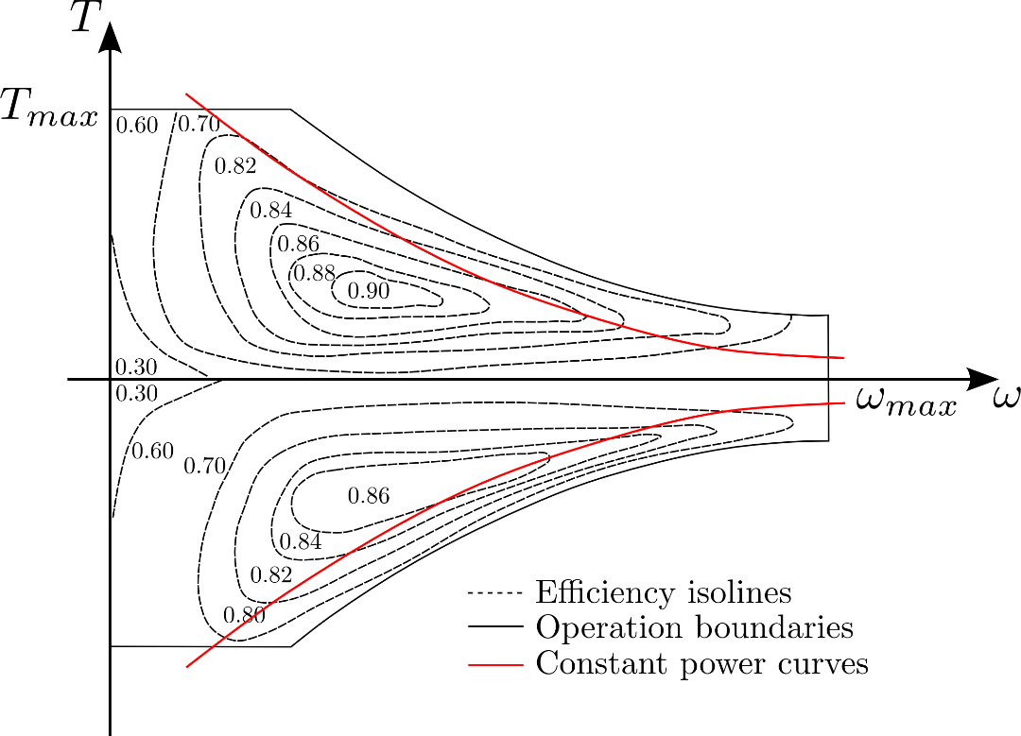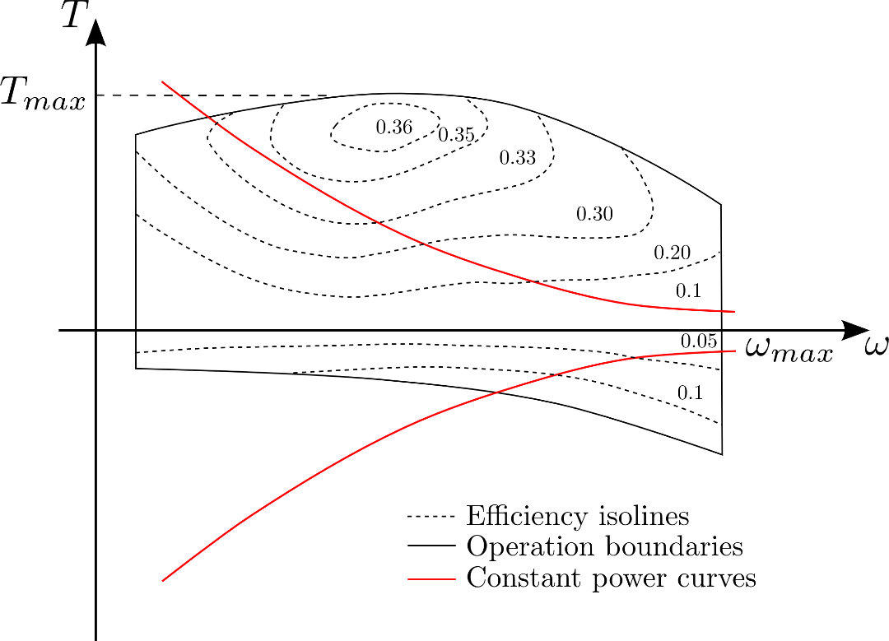

**Total accumulated EM input at 9.3 GR : 9.8027e+03 kJ**

**Total accumulated EM input at 3.6 GR: 9.9056e+03 kJ**

**Total accumulated EM input at 8 GR: 9.7040e+03 kJ**

**As the numbers above indicates, we need to find a middle ground in GR to get out the most from our system.**

**When I test every GR between 3.6 and 9.3 with 0.1 increments and used some code to find which GR that accumulated lest input power to EM. I found that a GR of 6.1 was the best. (See picture above and last lines of code in “plots_model3.m” to see how I calculated this.)**